Transaction with tokens

1. Buyer success & seller success

Compile & deploy SimpleToken.sol

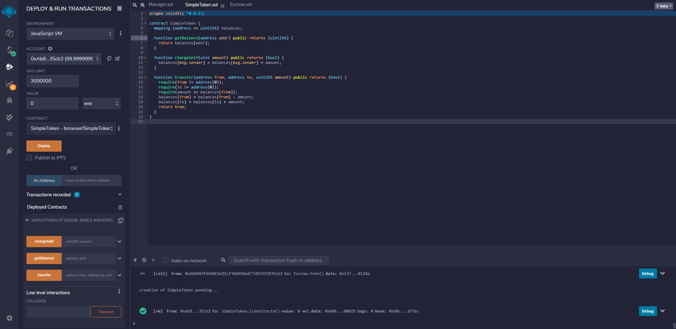

Compile & deploy Escrow.sol

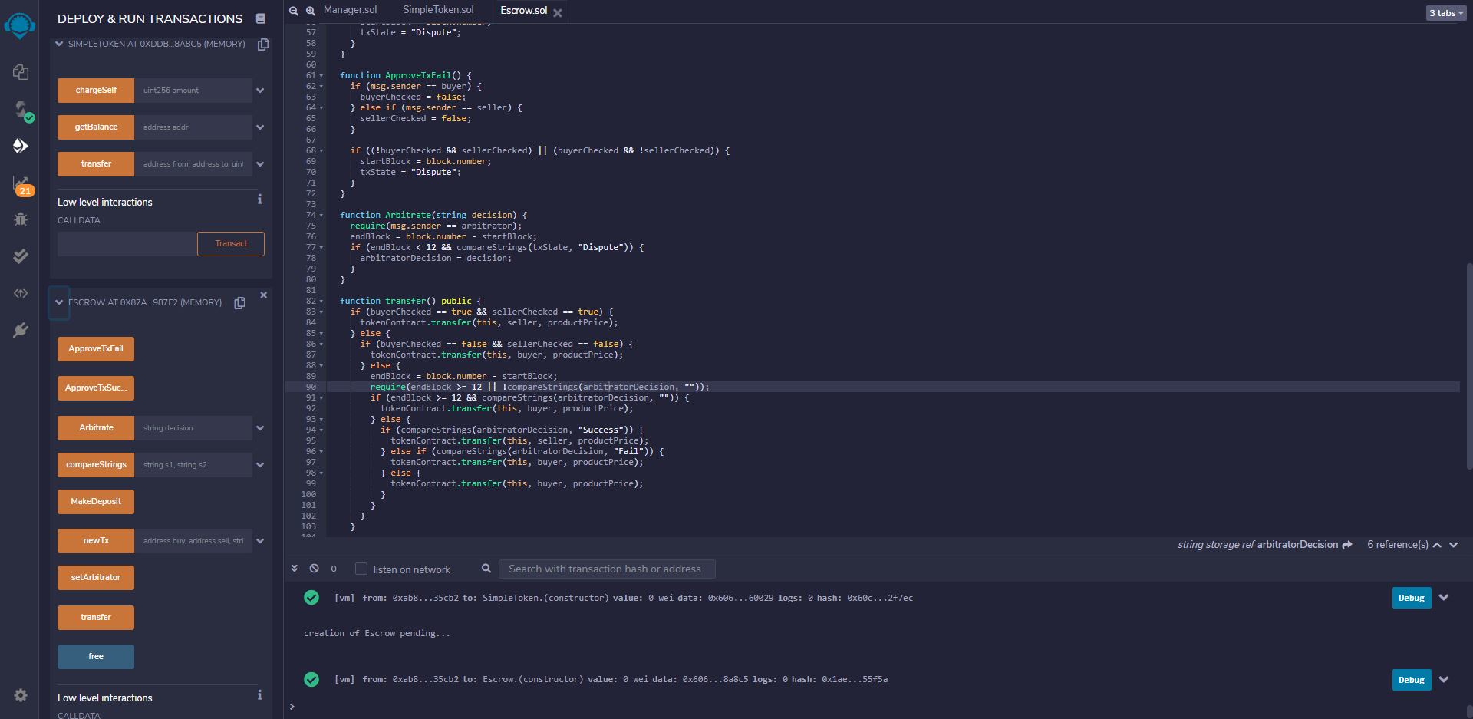

Compile & deploy Manager.sol

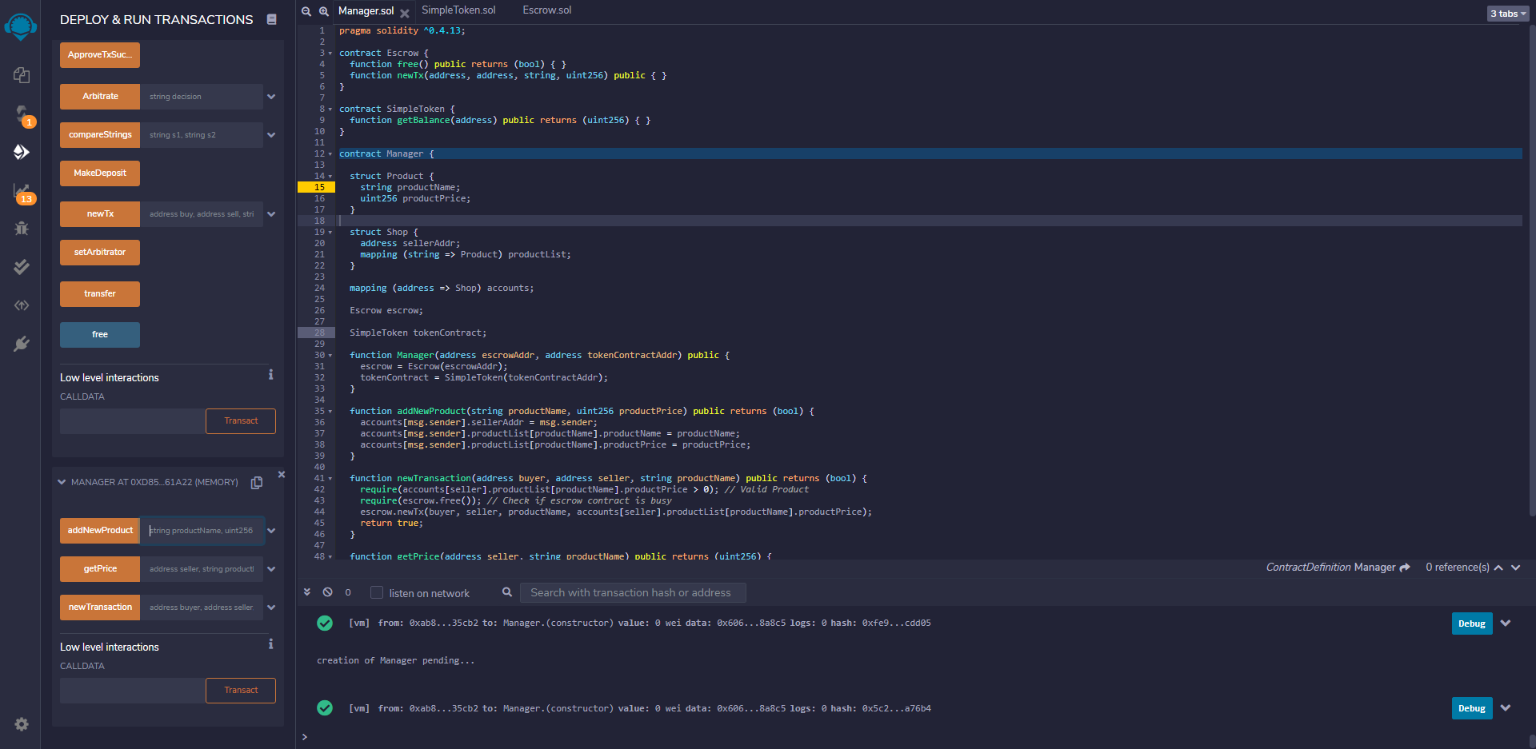

Seller – add new product

Product name – pen

Product price – 70 tokens

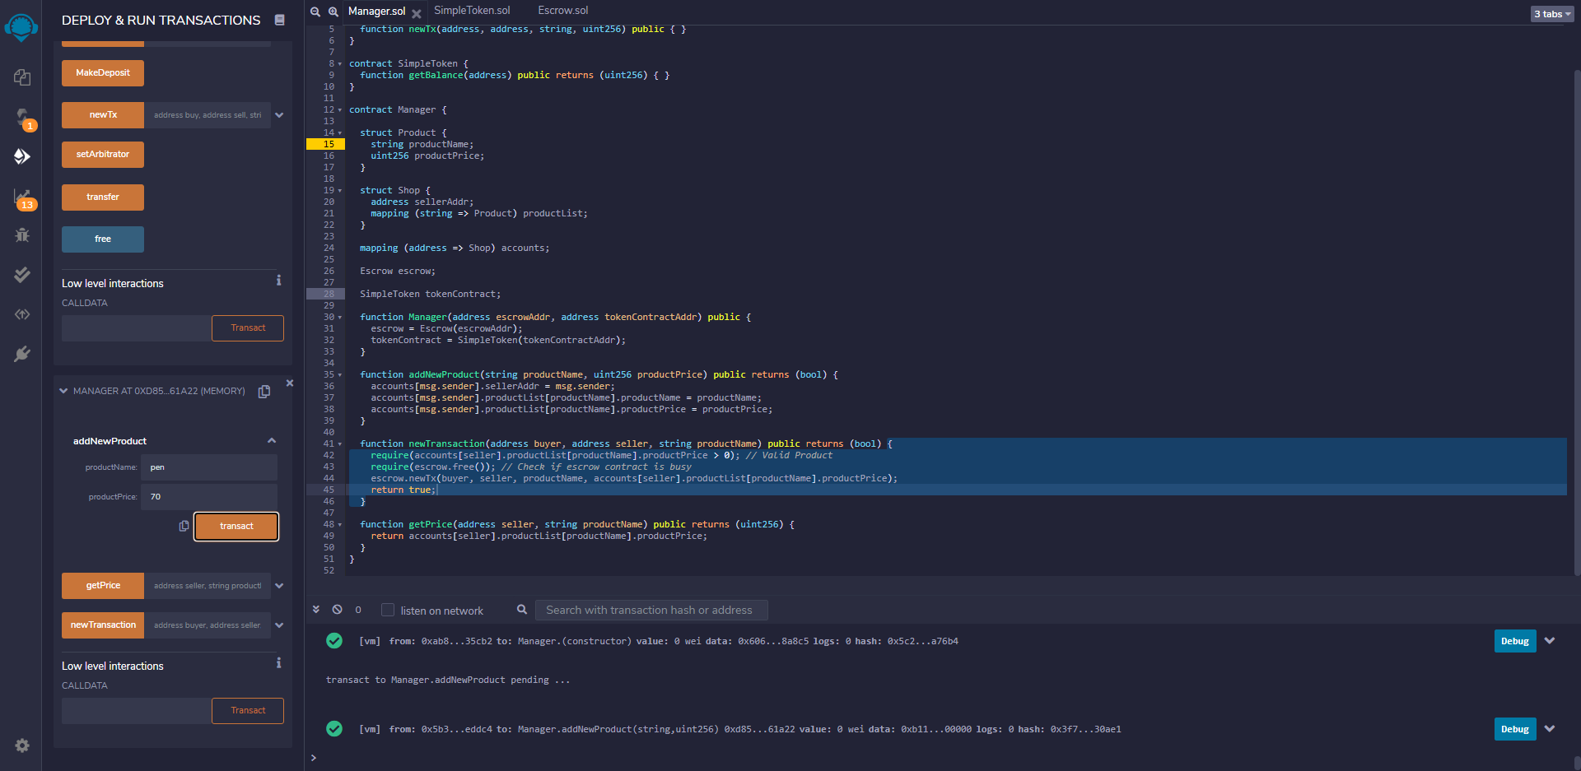

Buyer – purchase 100 tokens

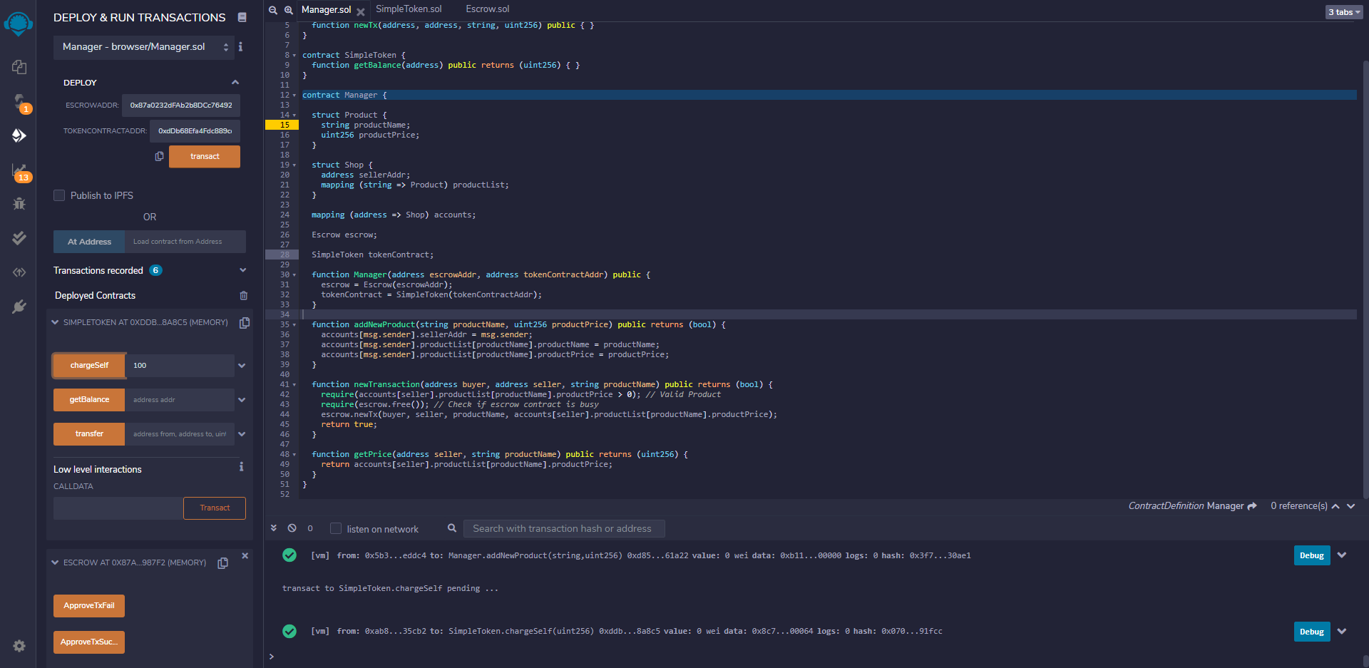

Seller – create new transaction

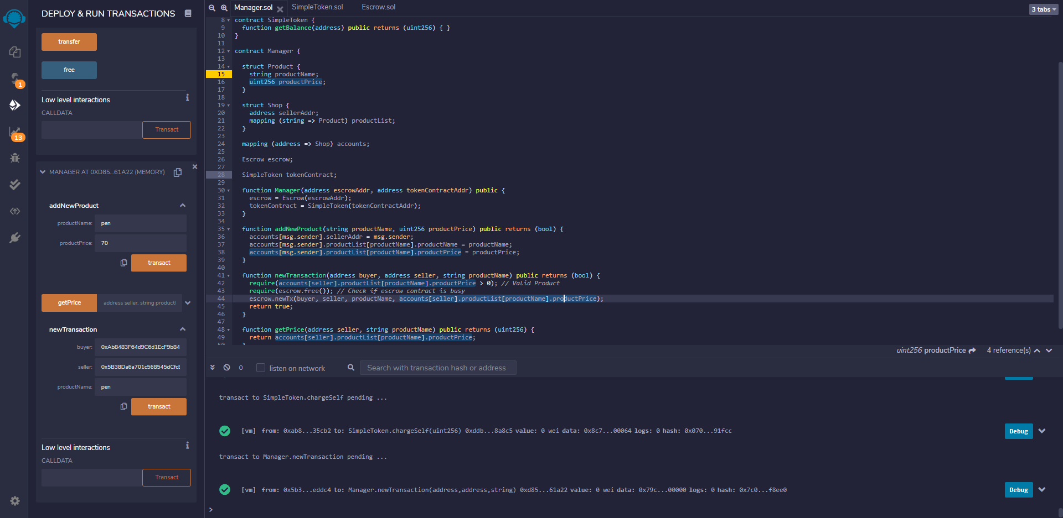

Buyer – make deposit

Amount – price of pen – 70 tokens

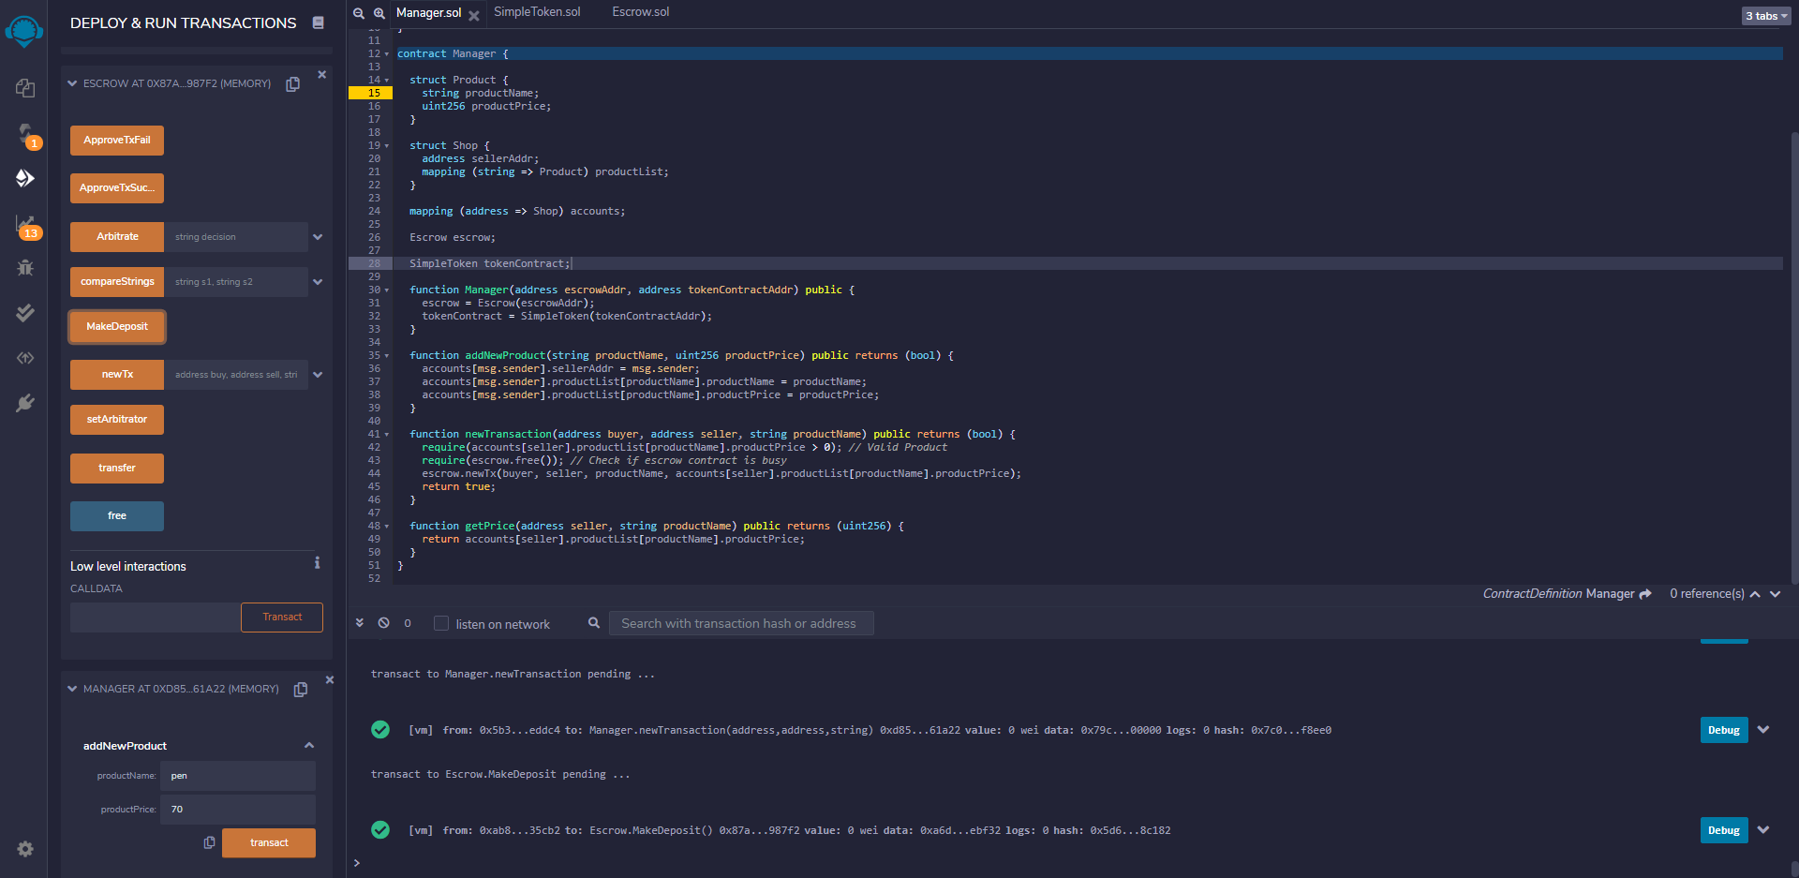

Buyer & seller - call ApproveTxSuccess function

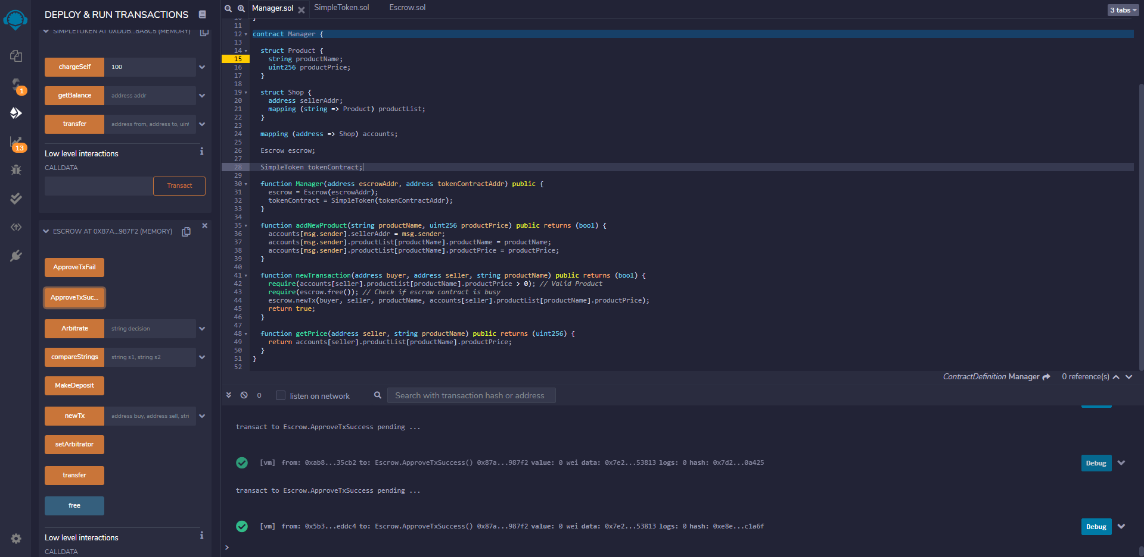

Call transfer function to finish the transaction

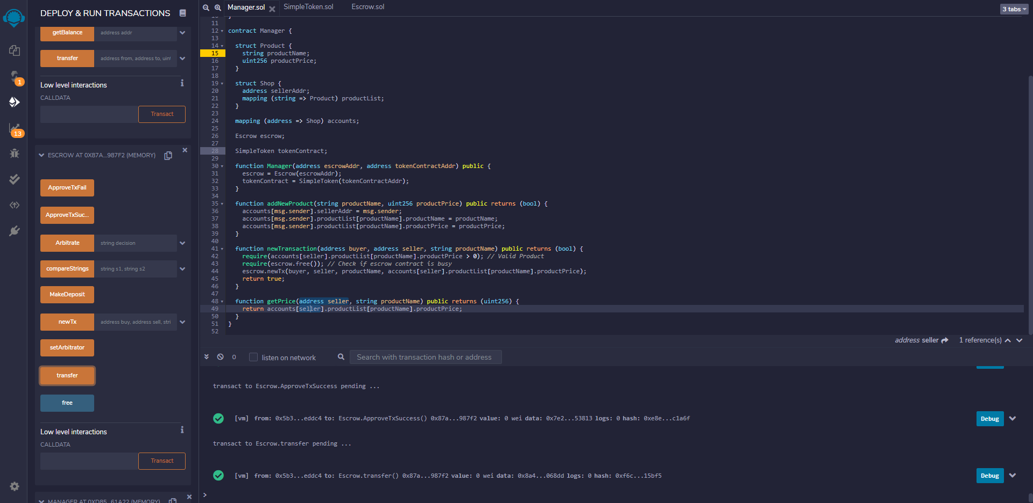

Seller – check balance

Got 0x46 = 70 tokens

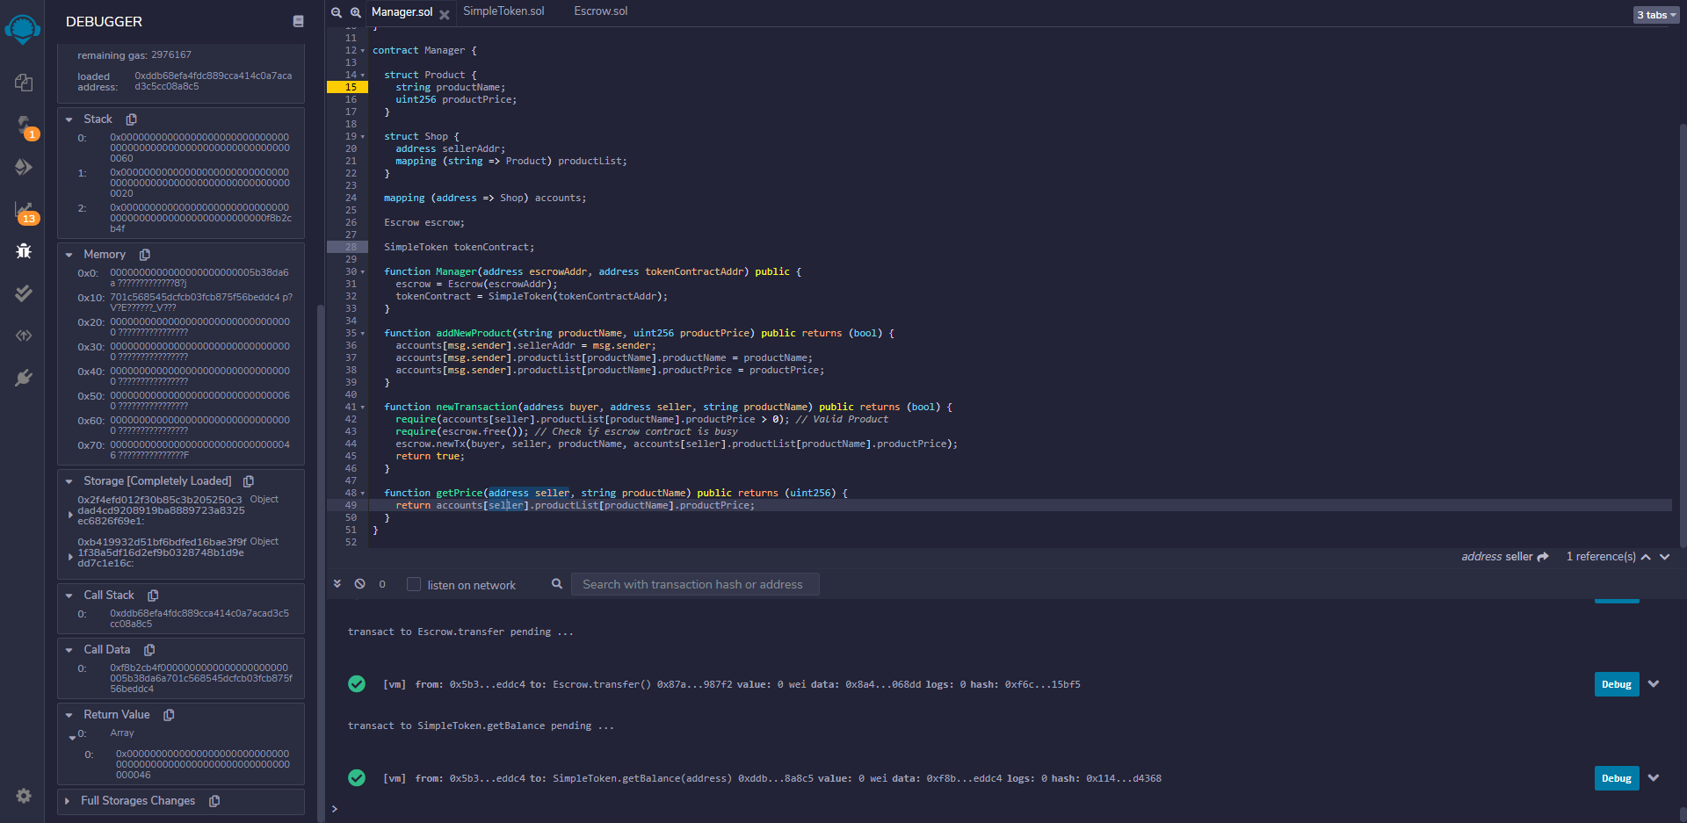

Buyer – check balance

Got 0x1e = 30 tokens

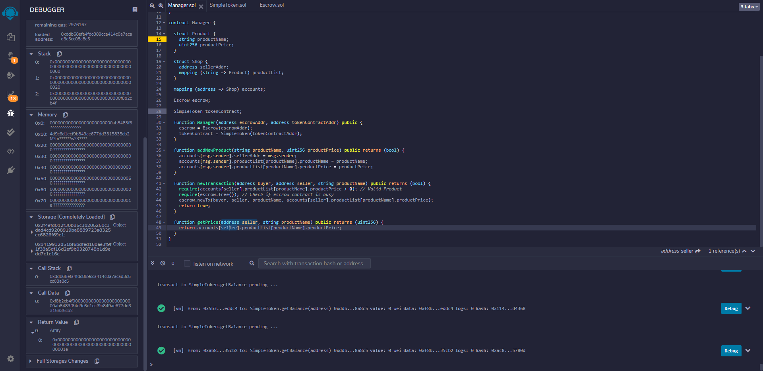

2. Buyer fail & seller fail

Buyer – purchase another 100 tokens

Now it should be 30 + 100 = 130 tokens

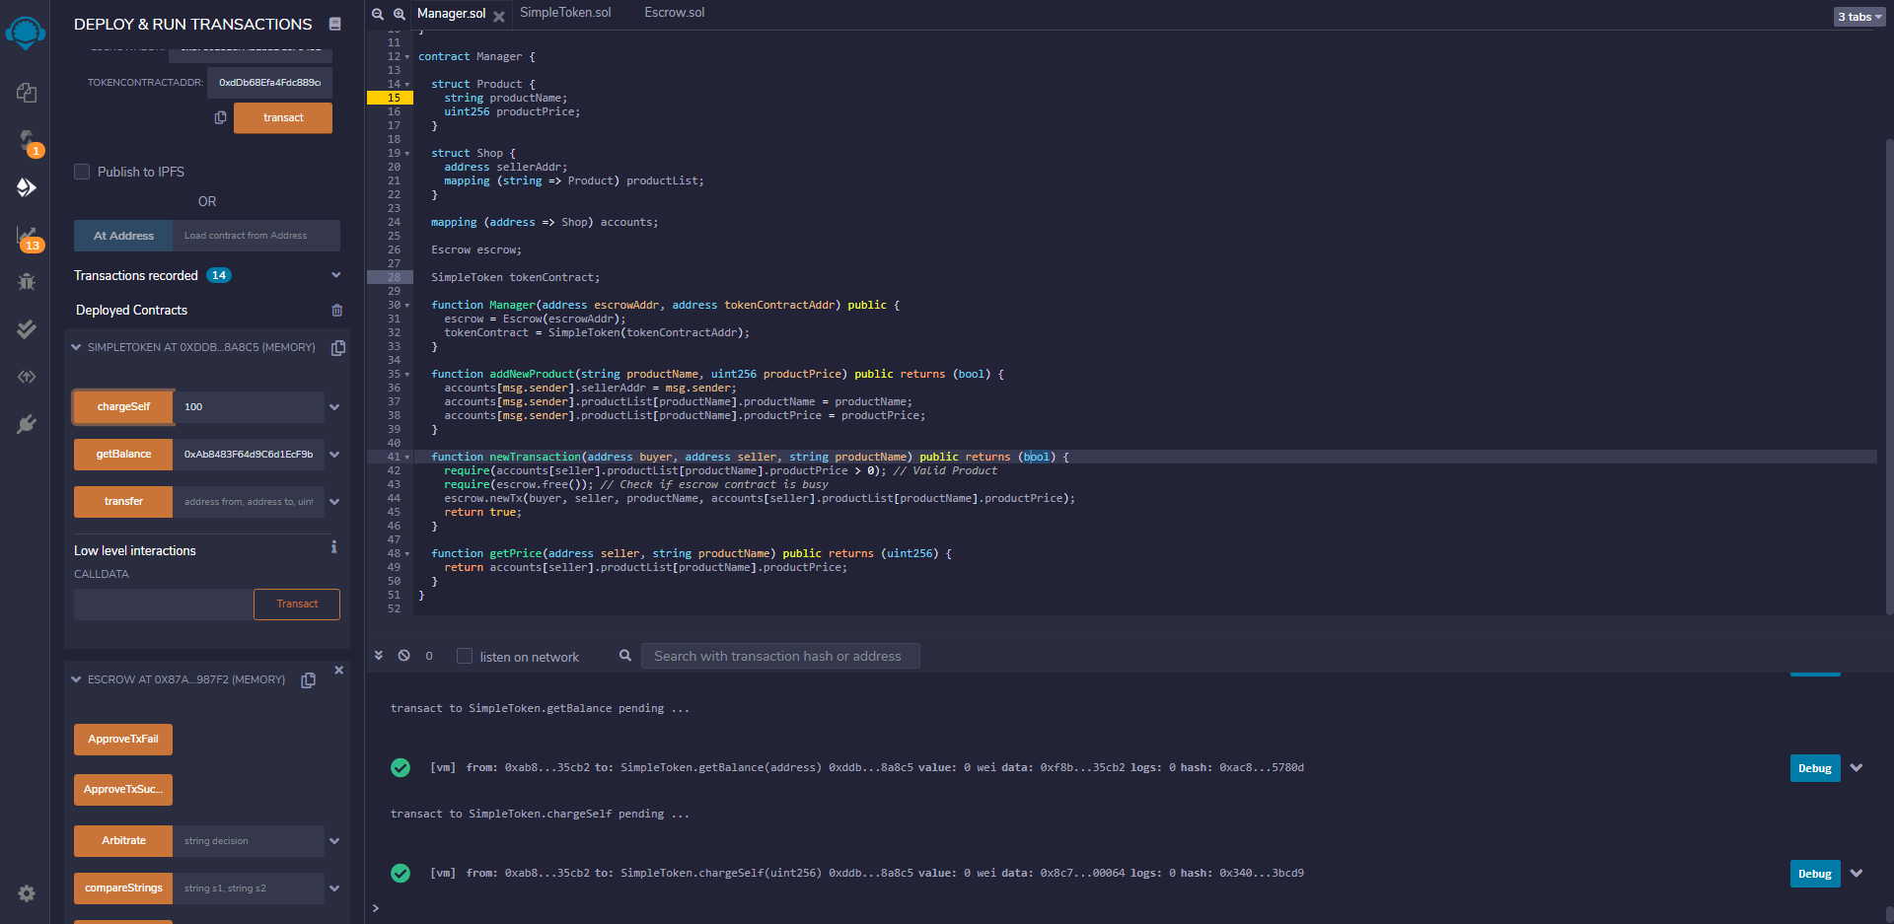

Seller – create new transaction

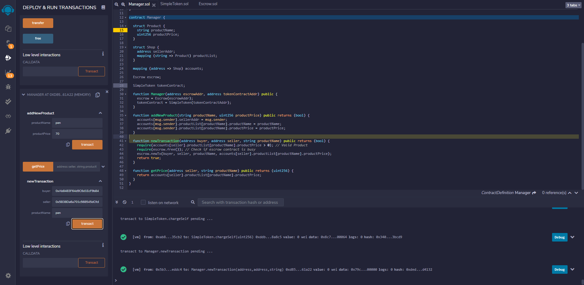

Buyer – make deposit

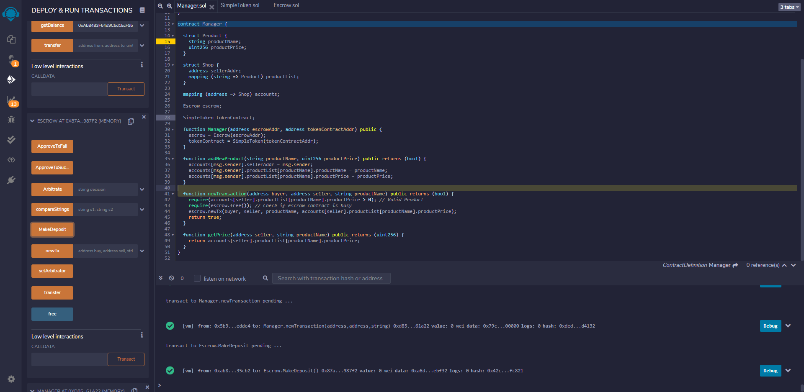

Buyer – check balance

Get 0x3c = 60 = 130 - 70

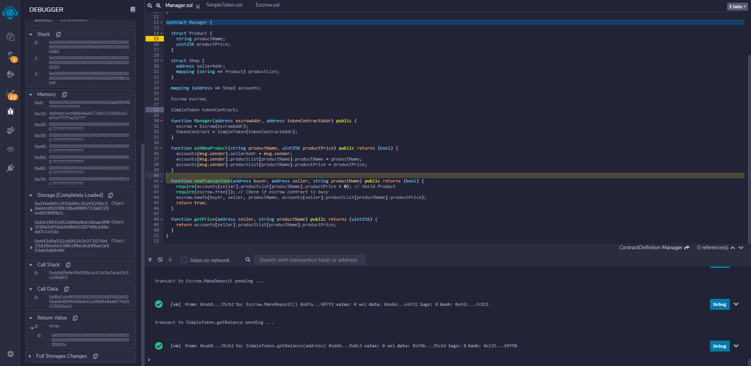

Buyer & seller – call ApproveTxFail function and then call the transfer function

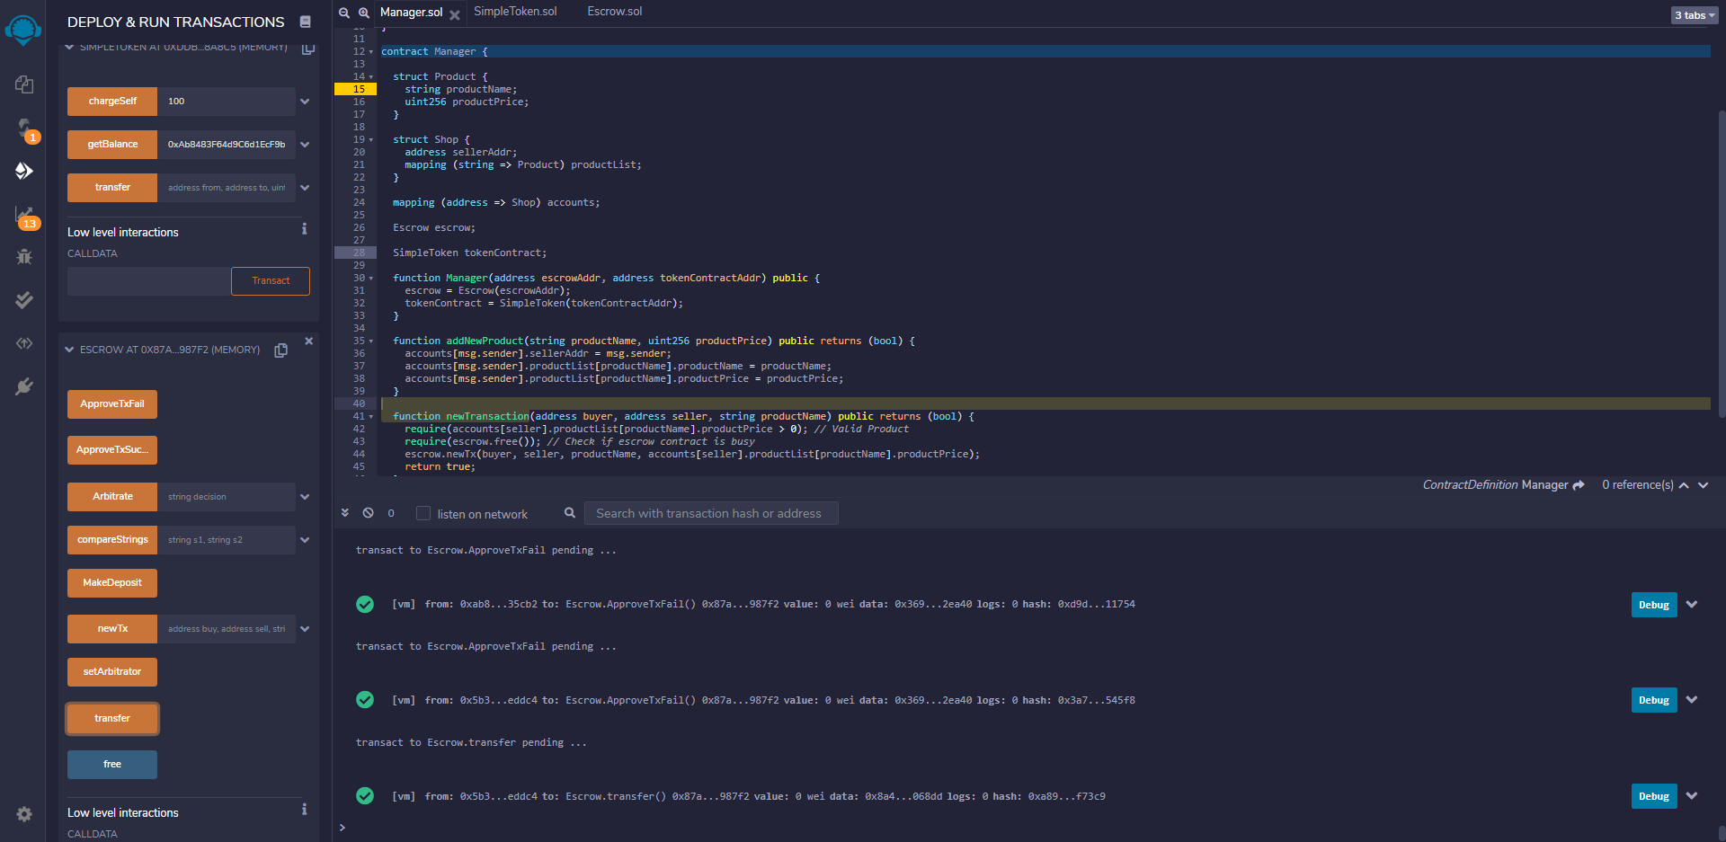

Buyer – check balance

Got 0x82 = 130 tokens

The 70 tokens deposit was refunded.

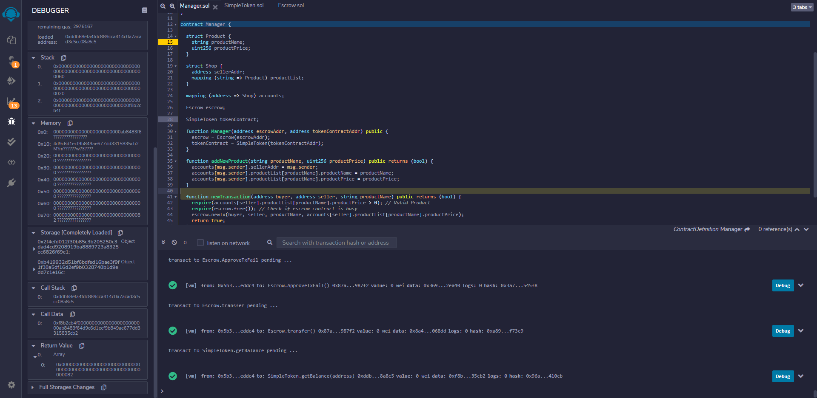

Seller – check balance

Got 0x46 = 70 tokens

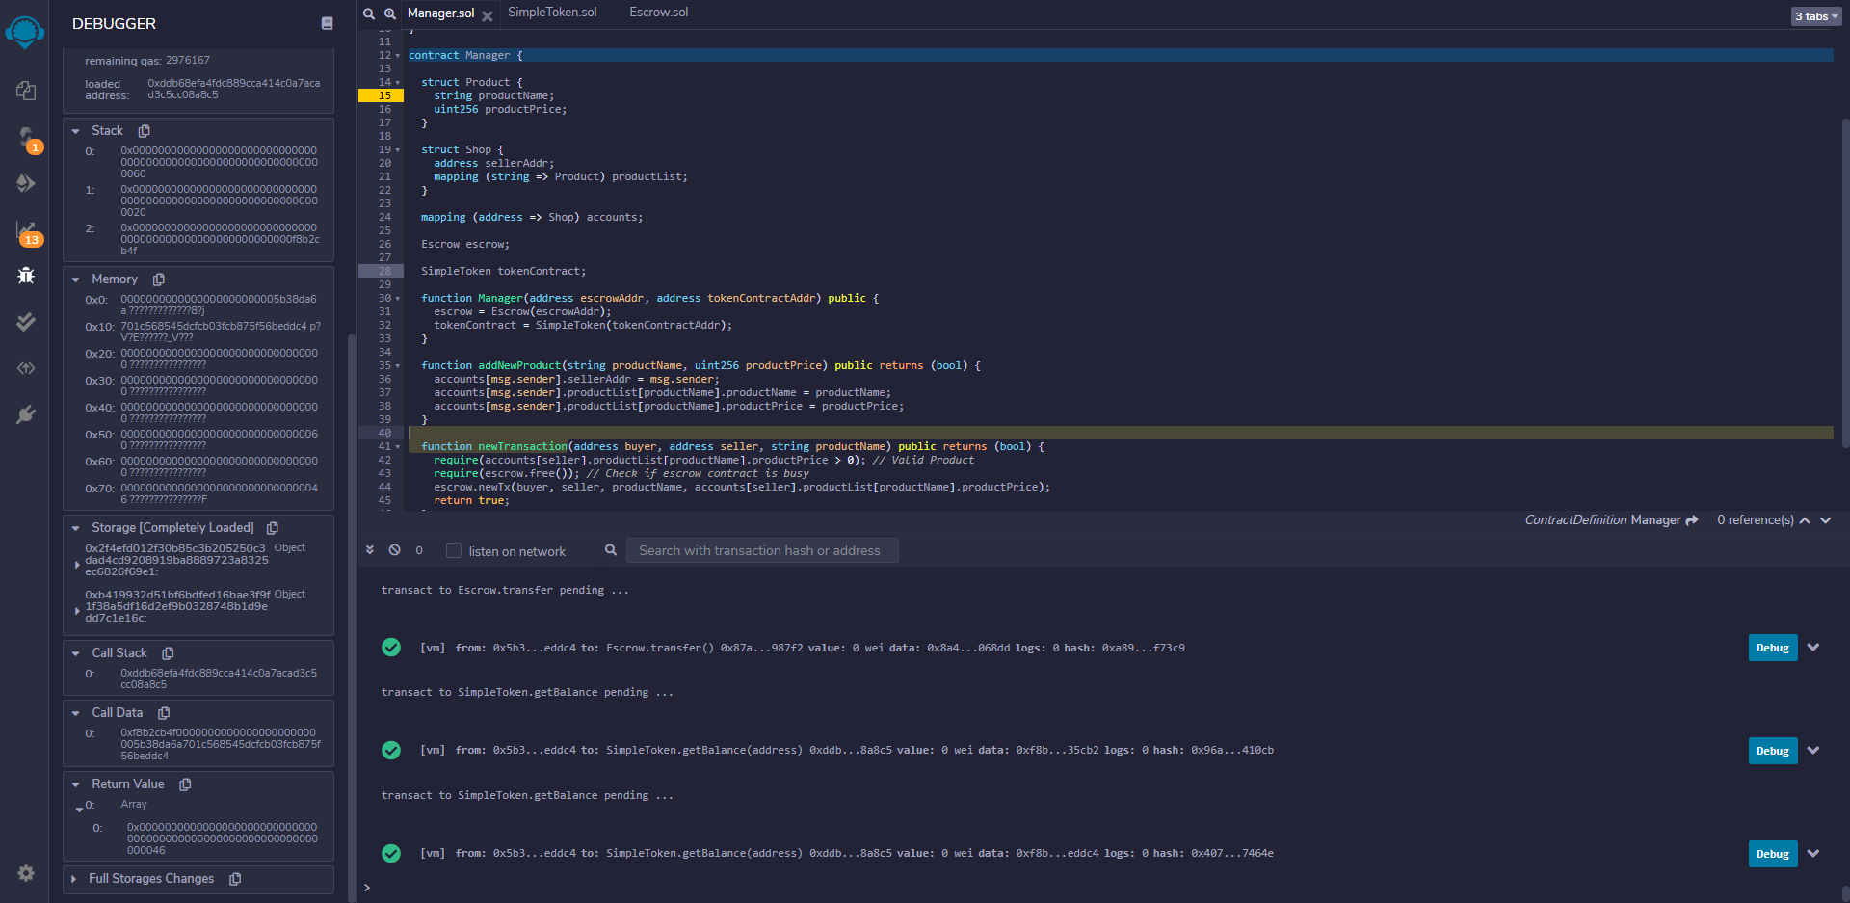

3. Buyer fail & seller success & arbitrator agree with the seller

Seller – create new transaction

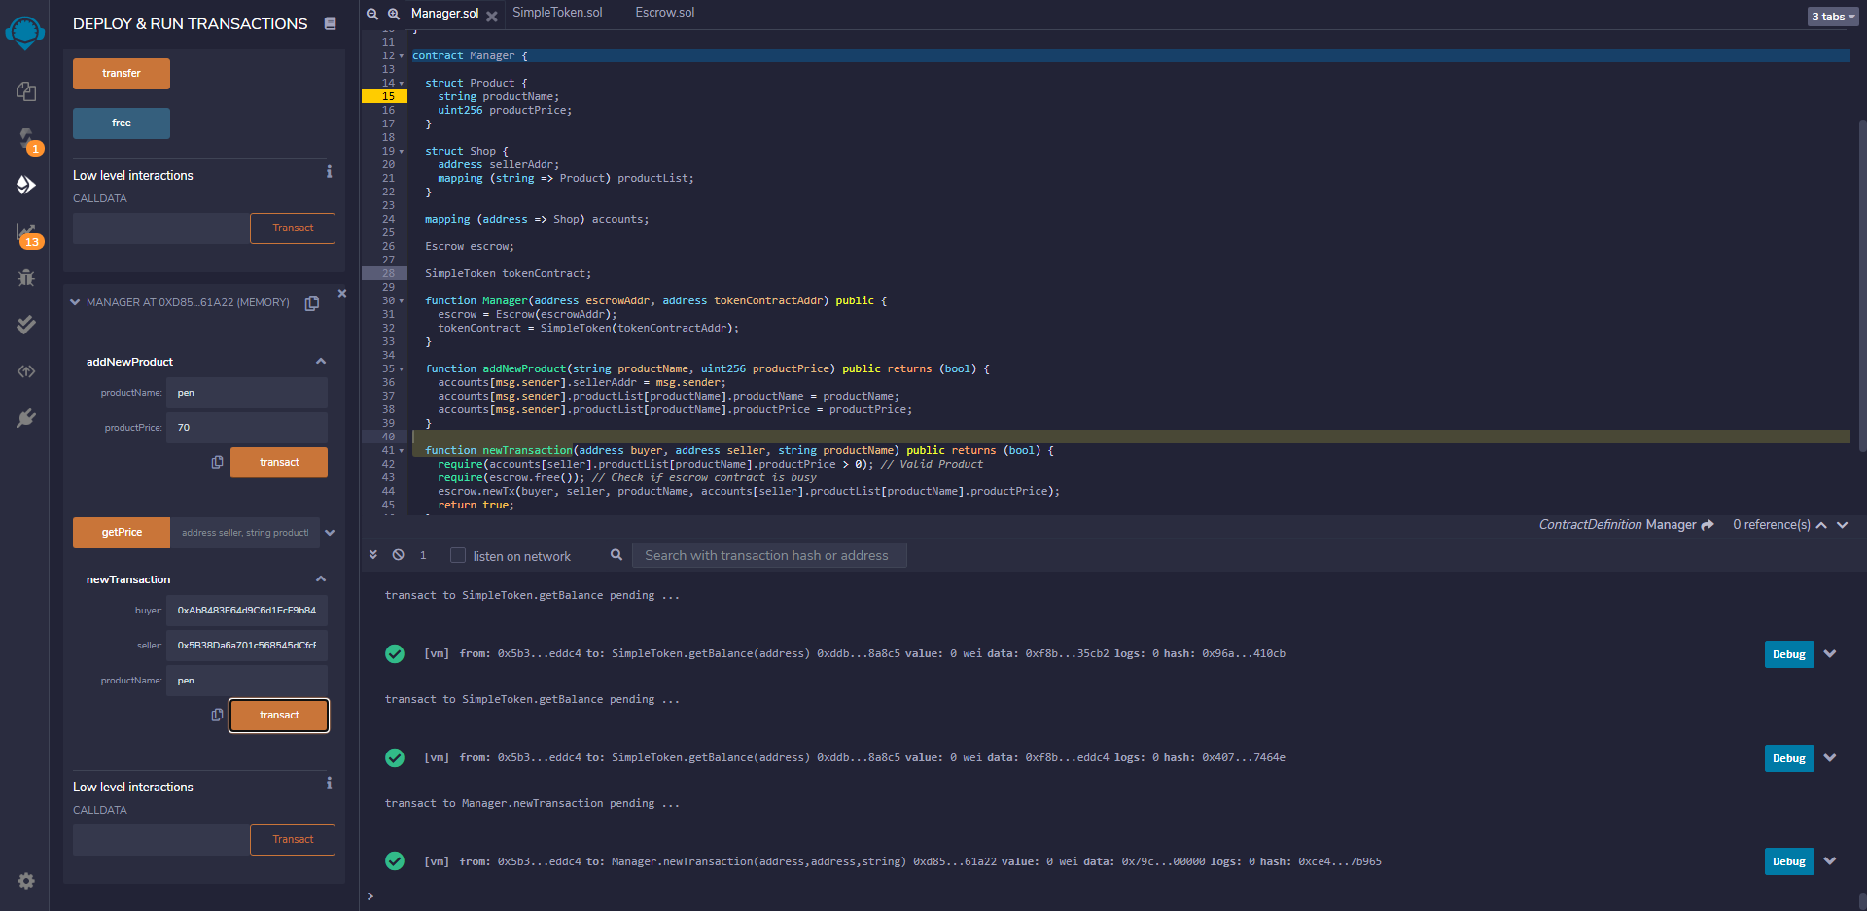

Buyer – make deposit then check balance

Got 0x3c = 60 tokens = 130 - 70

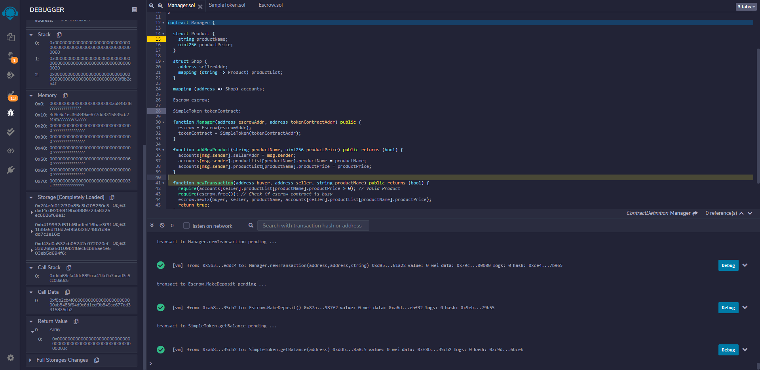

Buyer – call ApproveTxFail function

Seller – call ApproveTxSuccess function

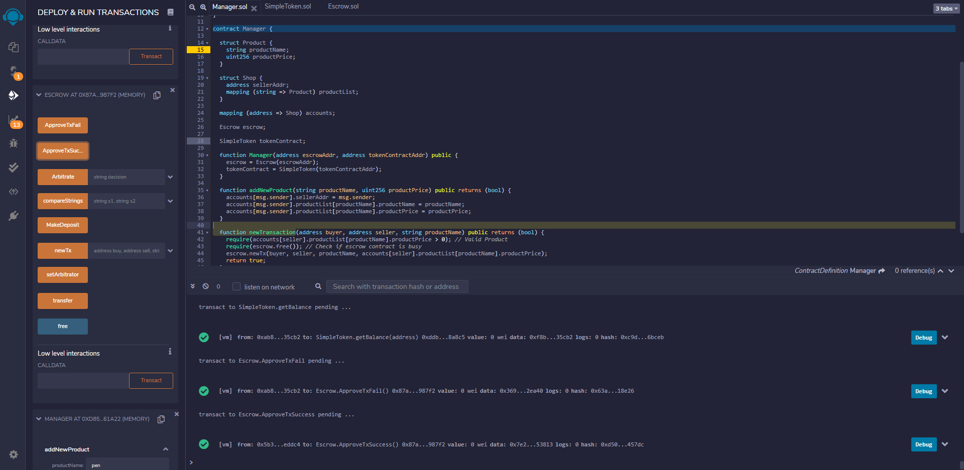

Arbitrator made decision "Success" and call the Arbitrate function

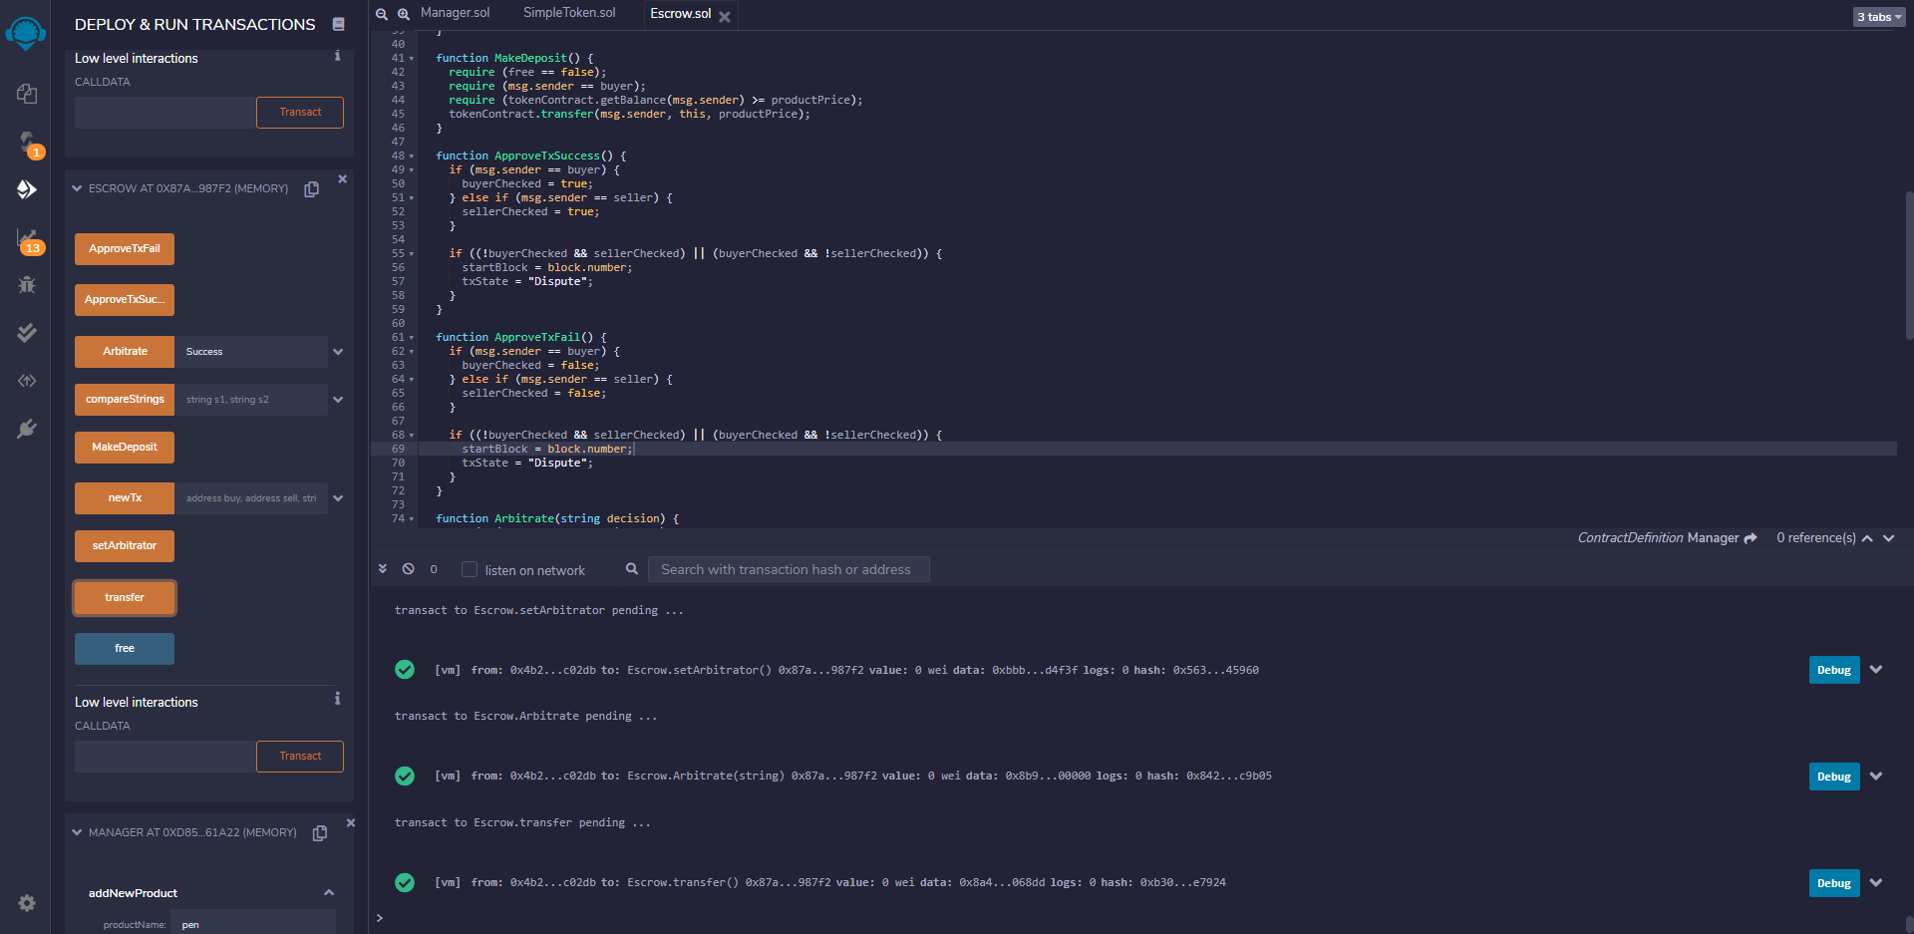

Buyer – check balance

Got 0x3c = 60 tokens

Not refunded

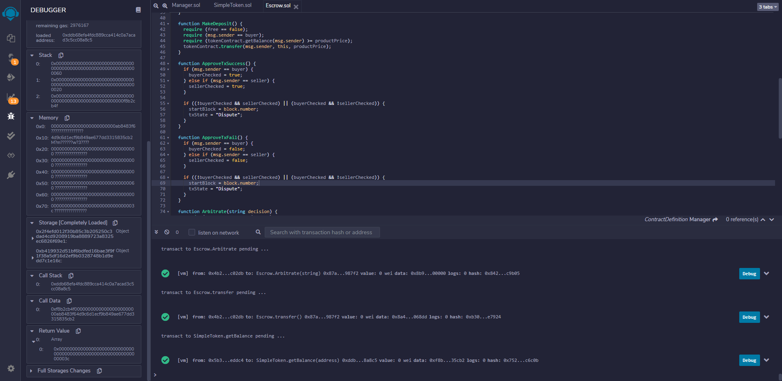

Seller – check balance

Got 0x8c = 140 tokens

The transaction has been approved because of the arbitrator's "Success" decision.

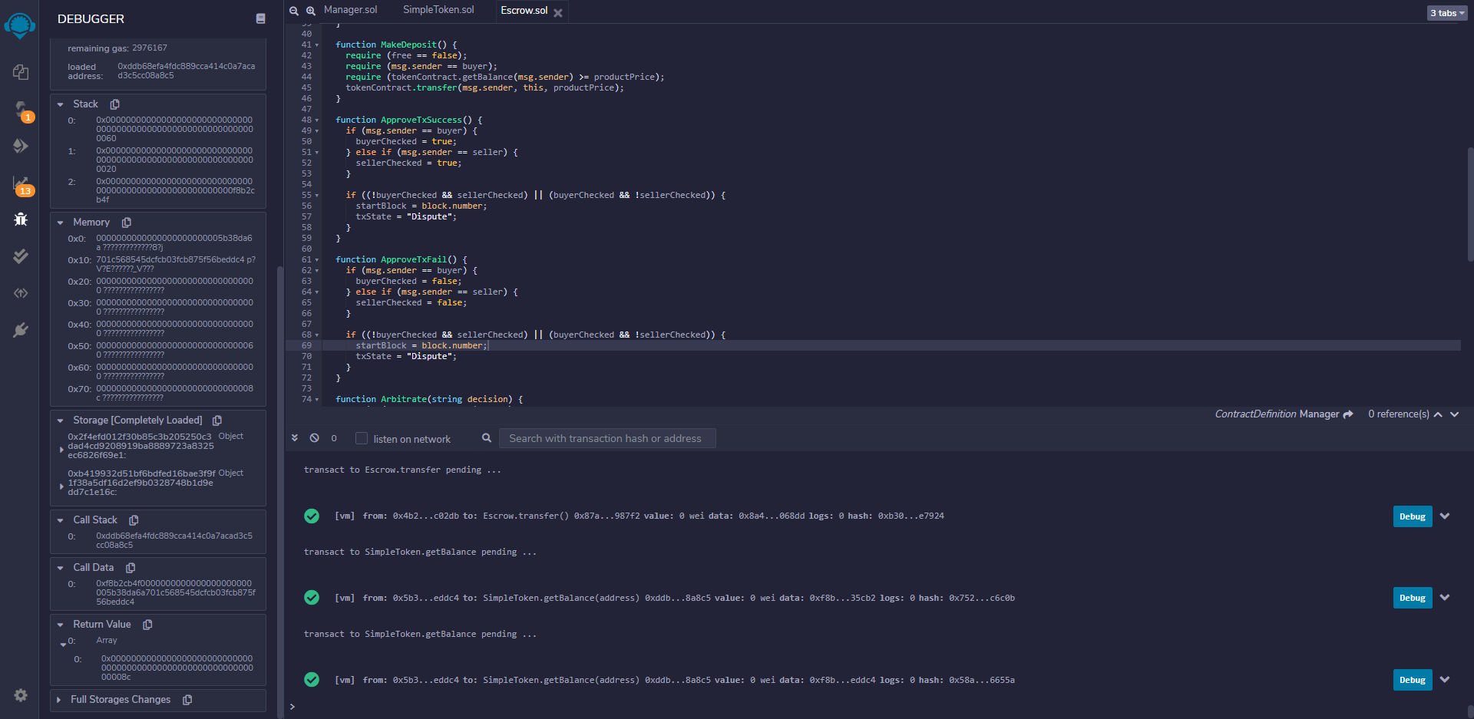

Transaction with Ether

Product Price = 30,000,000,000 Wei

Seller – the first account in the list

Buyer – the second account in the list

Function Calls – Screenshot 1

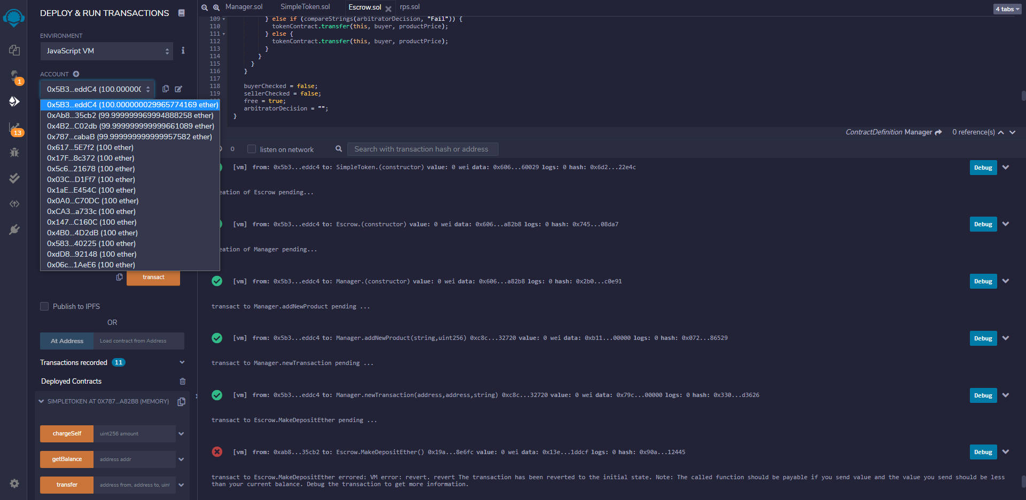

Function Calls – Screenshot 2

